PROJECT REPORT TEMPLATE

1 INTRODUCTION:

* 1. OVERVIEW:

1. A property management application is a software tool designed to help property managers streamline their day-to-day operations. The application can be used to manage various aspects of property management, including financial accounting, tenant management, maintenance requests, lease agreements, and more.

1. Property management applications can be cloud-based or installed locally on a computer or server. Some applications are designed specifically for residential properties, while others are tailored for commercial properties. Additionally, some property management applications may offer integrations with other software tools, such as accounting software, marketing software, or maintenance software.

* 1. PURPOSE:

The purpose of property management is to oversee and manage real estate properties on behalf of property owners. Property management involves various tasks such as rent collection, tenant screening, property maintenance, lease agreement administration, financial management, and more. The ultimate goal of property management is to ensure that the property is profitable and well-maintained, while also providing a positive experience for tenants.

2 PROBLAM DEFINITION & DESIGN THINKINHG

2.1 EMPATHY MAP:

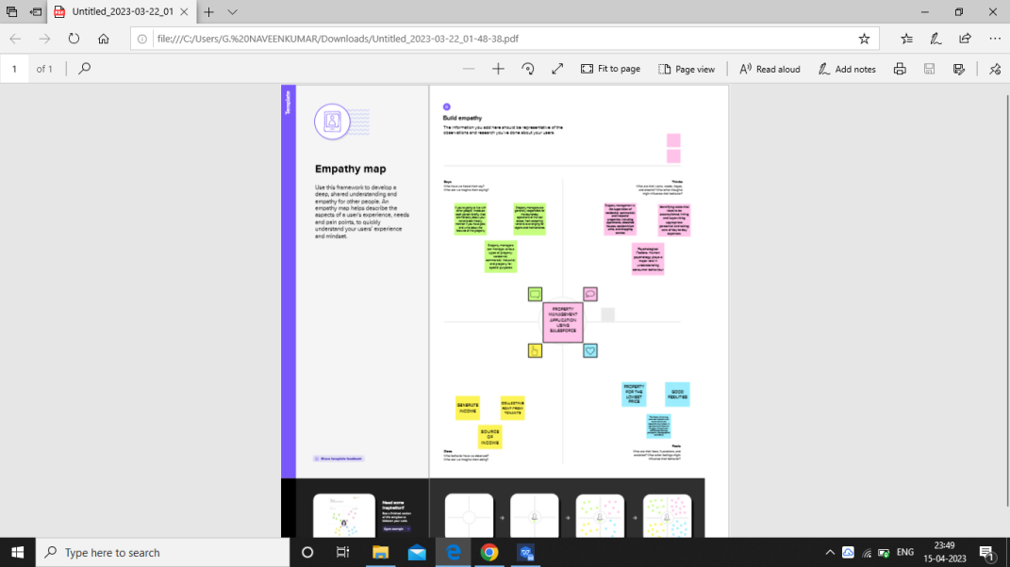

2.2 IDEATION & BRAINSTORMING MAP:

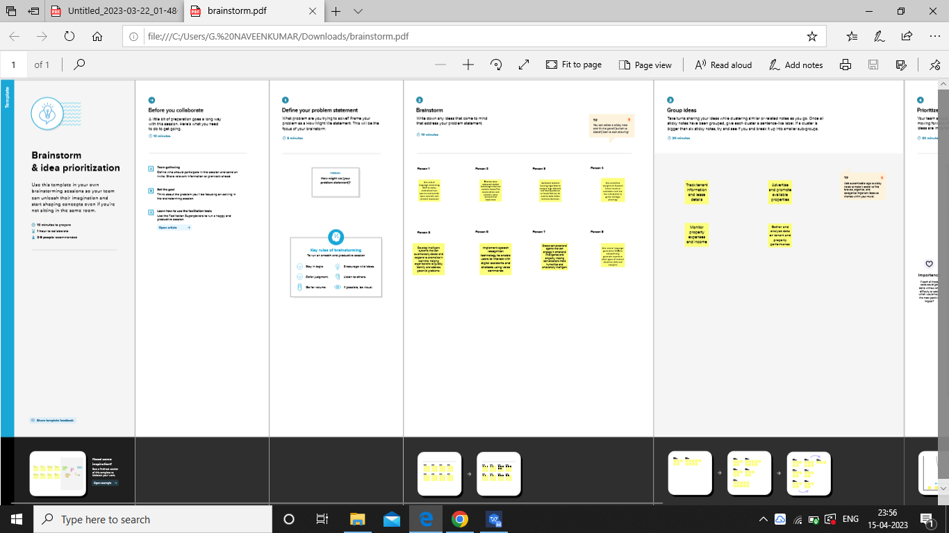

3.1 Data Model:

|  |  |  |
| --- | --- | --- |
| Object name | Field in the object | |
| Object 1 | Field label | Data type |
| Lead_c | Data/type |
| Owener ID | Lookup(user,group) |
| Object 2 | Field label | Data type |
|  | Rent__c | Auto Number |
| Name | Text(80) |

3.2 Activity & Screenshot

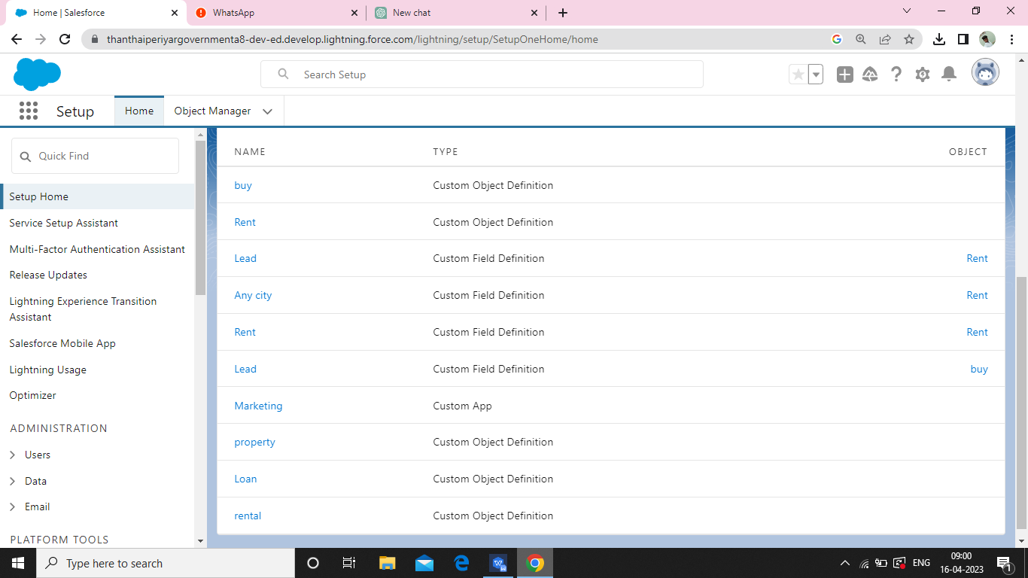

4.TRAILHEAD PROFILE PUBLIC URL :

TEAM LEADER -<https://trailblazer.me/id/nkumar2837>

TEAM MEMBER 1-<https://trailblazer.me/id/rramamoorthi2>

TEAM MEMBER 2-<https://trailblazer.me/id/rramesh113>

TEAM MEMBER 3-<https://trailblazer.me/id/rkumar4924>

1. ADVANTAGES & DISADVANTAGE

ADVANDAGE:



Time-saving: Property management applications can automate repetitive tasks, such as rent collection, maintenance requests, and tenant communication, which can save landlords and property managers a lot of time.

* *****Time and energy for you:*****Do you have a full-time job and want to use the rental property as a source of passive income, or do you want to be heavily involved in the management of the property? Managers can handle every aspect of managing a rental property.  They will give you more time for yourself and no direct responsibility for tenant responsibility.  This will give you the peace of mind of knowing that your property is well taken care of.

DISADVANTAGE:



*****Loss of control:*****If you are the kind of property owner who wants to have total control over every aspect of your business, hiring a property manager is certainly not the best call for you. When you hire someone else to run your rental business, you’re giving up a lot of control over how things get done. A property management company will hire its own employees, screen and approve tenants without your input, and may even make superficial changes to the property in the course of conducting maintenance or upgrades.

2.

* *****Expense:*****For the budget conscious property owner, hiring a property manager may feel like an unnecessary expense. The biggest obstacle people see when determining if they want to hire a property manager is the cost. Property management is a paid service, and those initial dollar signs can deter people that think they can do it themselves. A property management fee might be close to 10% of your rental income, which is significant. Some companies charge property owners based on the size of the rental property, the condition of the property, and the type and location of the property.

1. APPLICATION:

1. Find **Property** Managment Software. Now with us! Search For **Property** Managment Software at findresultsnow.co. Awesome Info. Get Latest Info. Attractive Results. Search Now. More Info. Updated Info. Get More Results. Relevant Results. Latest Today. Fast Response. Services: Answers, Information, Social, Related Searches.
2. Search For **Property** Managment Software at Bestdiscoveries.co. Find **Property** Managment Software. Now with us! Attractive Results. Search Now. Get More Results. More Info. Get Latest Info. Relevant Results. Fast Response. Find it Here. Awesome Info. Updated Info.
3. CONCLUSIONL:

Find **Property** Managment Software. Now with us at Smartsearchresults.com! Search For **Property** Managment Software a Smartsearchresults.com. More Results Than Ever. More Relevant. Look For More. More Here. Relevant Information. Now More. Services: Online Search, Stories, World Wide Web, Information.

1. FUTURE SCOPE:
2. Data and Analytics. Data and its management and analytics are the lifeblood of modern project management. Managers must leverage data insights to make fast and informed decisions that contribute to business growth. Big Data analytics is a fast-impacting trend in the landscape of project management.
3. Create your scope plan. The first step in the planning process involves creating your scope plan document. This document should include your scope statement, a breakdown of project

requirements, and any expected deliverables for the project. Your scope plan document may also include a change control process, which is a process for change ...